Our Favorite Places to Eat
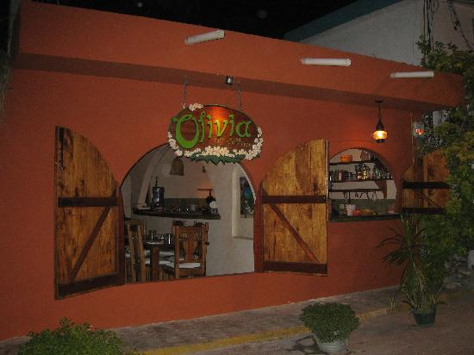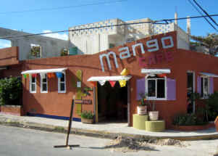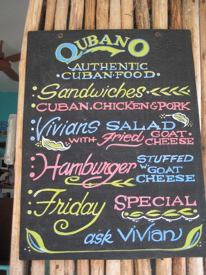
Olivia’s – A Must!!!
Olivia’s is one of our favorite places to eat. It serves a homemade Mediterranean cuisine and is only open for dinner. It is owned by Lior and Yaron, a lovely Israeli couple who have made Isla their home. All of the menu items are amazing. The Toppa appetizers are a must! If you pass the restaurant in the morning Gardner orders the Chicken and Olives every time we dine with them. The chicken really does fall off of the bone. The garden setting is the most romantic place to dine on the island. Opened only for dinner Tuesday – Saturday.
Mango Café – A Must!!!!
Mango Café is one of the best restaurants on the Island (or in the world as far as I’m concerned.) Lori, the owner serves a fusion of tastes from Mexico, the Caribbean and Jamaica. The BLGT’s (Bacon Lettuce, green apple Guacamole and Tomatoes) are served with homemade mayo on fresh whole wheat bread…truly gourmet! Everything on the menu is a treat! It is in the Colonia’s which is a short cab ride from the north side. Open daily for breakfast & Lunch. Also open Mondays only 5pm-9pm. The owners opened the Blue Iguana across the street with more of a deli menu opened 8am-6pm (closed on Tuesdays).
Qubano’s – A Must!
Qubano’s sandwiches are amazingly good. The owner Vivian serves an authentic Cuban sandwich which she roasts the pork and saves the juices and fat to sauté the final sandwich. She also serves an amazing Vivian salad and a goat cheese hamburger that the goat cheese drips out of the center when you bite into it. Sides include yucca fries and Hungarian potatoes…all yummy good! Open Monday – Friday from noon-4pm.

Our Favorite Places to Eat

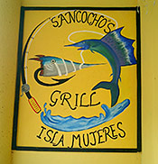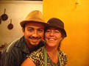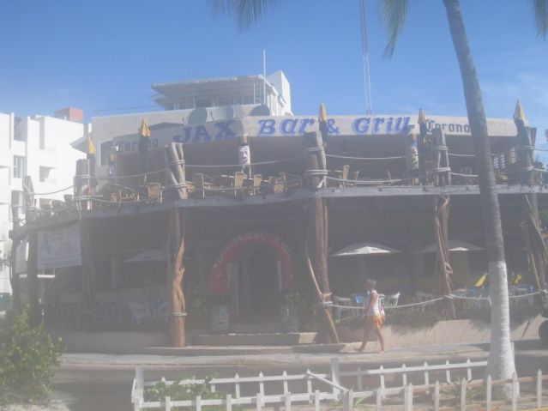
Sancocho’s – A Must!
Sancocho’s is well known for their fish filet with dark rum sauce & flower fish. They also have a wonderful Azteca soup that is similar to our tortilla soup. Its owner’s Alex & Maggie started as a maid and bar-back and after much sacrifice, have proven to be successful entrepreneurs. This is also one of our favorite Wi-Fi sports bars.
LoLo Lorena’s

LoLo’s
LoLo’s is located mid-island just a few doors down from the Navy Hospital, LoLo is from Belgium and 0ffers private dinners at her charming home. Although pricey (approx $35/person), She is a gourmet chef and the experience is worth every penny. Her homemade lasagna is out of this world!
Jax Bar and Grill
Jax’s is a lively bar and a great place to watch the sunset as well as your favorite sports teams. They are known for their hamburgers, fish tacos and friendly bartenders. The owner Jackie is a fun feisty girl from Dallas who has made Isla her home. This is also a GREAT breakfast spot. Our younger children eat almost every meal here. Jax’s is also a good Wi-Fi spot. They are open for breakfast lunch and dinner
Bamboo
Bamboo’s menu has lots of good choices. They offer steaks and seafood and a bit of Thai. They always have good daily specials. The owner Jeff also provides live music in the early evening which makes for a nice place to have a drink before dinner. They are open daily for lunch and dinner.

Our Favorite Places to Eat
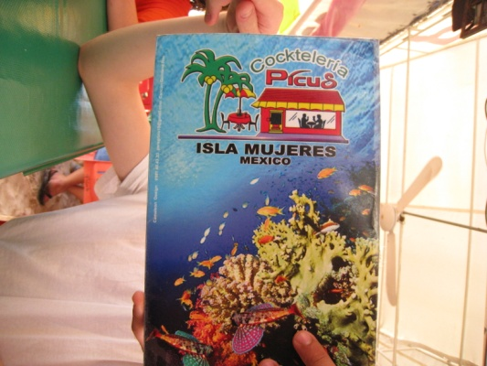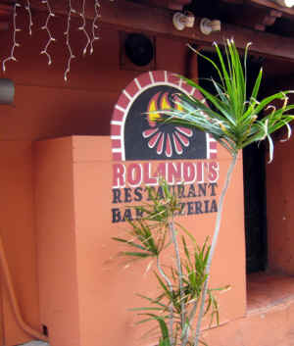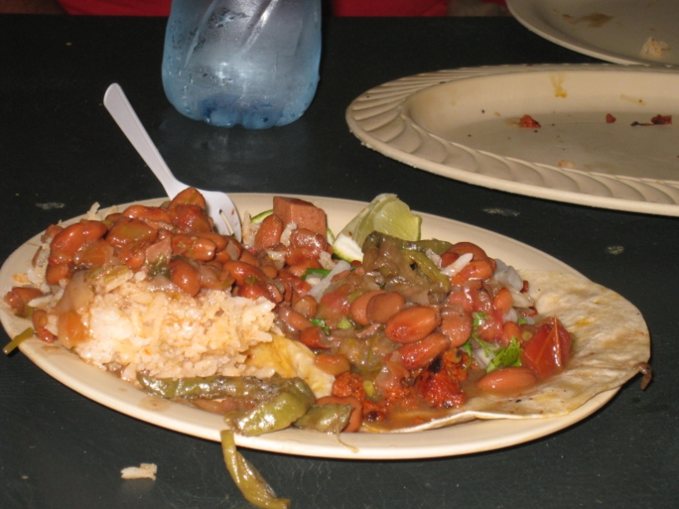
Picus cockteleria
Right on the water, the sand bottom floor feels like old Mexico. The shrimp cocktails and ceviches are fresh and come highly recommended. A great place to grab a snack
Rolandi’s Pizza
Rolandi’s is the closest thing to American food on the Island. They serve a good wood oven baked pizza and an extensive assortment of pastas. They are located on the main street Hidalgo and are open for lunch and dinner.
Baseball Stand Tacos
This restaurant used to be located at the baseball field. It is now hard to find but worth the search. The pork, beef and chorizo are cooked Brazilian style on a spit. You have your choice of flour or corn tortillas. The fixings bar has beans, rice, salsa, onions, radishes and marinated nopal cactus. It is one of the least expensive places on the Island.

Our Favorite Places to Eat Breakfast

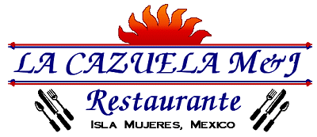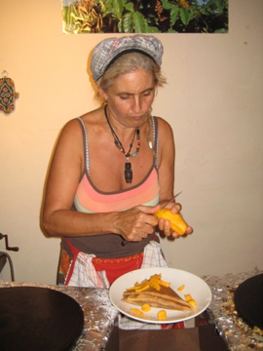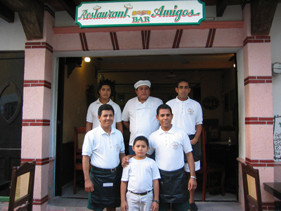
M & J’s - A MUST!
M&J’s is our favorite Breakfast place. The La Cazuela is the creation of its owner Marco. It is an egg dish that is half omelet and half soufflé served bubbling hot in a clay dish. Marco and his lovely wife Julie are wonderful friends. It is Mia’s favorite breakfast in the world! Pedro is M&Js longtime waiter and always serves everything with a smile. They are located in Hotel Xbulu-Ha which is on Guerrero between Madero and Morelos

Hidalgo Café
Hidalgo Café is known for their homemade crepes that they make right in front of you. Banana Nutella is an Emily Elkins’ favorite. The coffee is also wonderful.
Aluxes - A MUST!
Aluxes is our favorite Coffee shop on the Island. The owner Ivan and his wife Jenny make homemade breads each morning as well. They offer Isla's largest array of exotic teas, pastries and desserts. Stop in for a New York cheesecake or a triple fudge turtle brownie.
Amigos
We like Amigos for breakfast. Their menu specializes in Mexican and vegetarian dishes. They are open for Breakfast, Lunch and Dinner
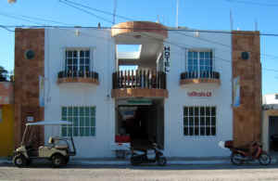

Our Favorite Places to Drink
Rommy’s Bar at Hotel Posada Del Mar
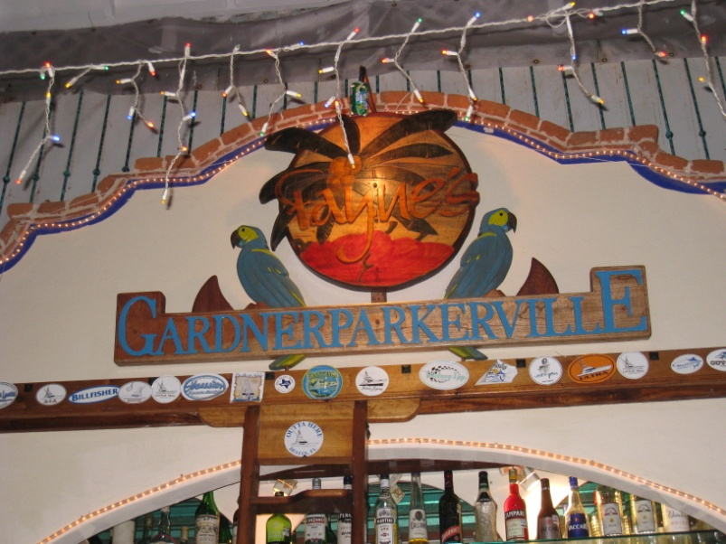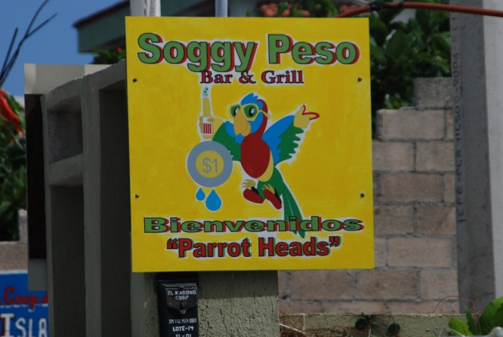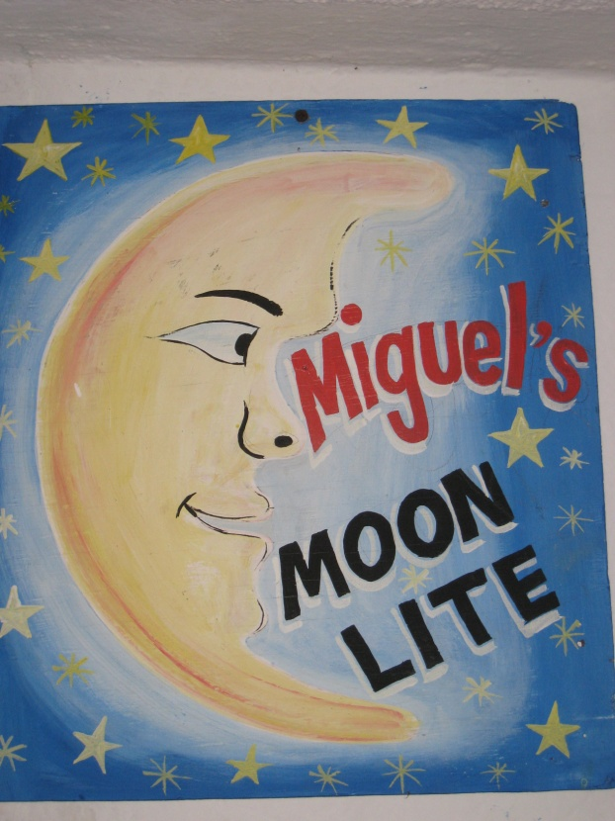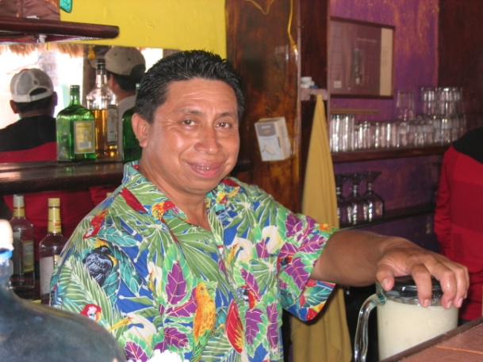
Fayne’s – (GardnerParkerville) is owned by our great friend Juan. We were honored in 2009 when he named his bar in honor of Gardner. This is our favorite late night bar and we rarely miss a night here when we are on the Island. The band is lead by our talented friend Javier, who plays nightly from 10pm – midnight. They play lots of old and new American favorites. They welcome tourist with (or without <wink>) musical talent to sing or play with the band. This bar is a fun and happy place that brings out dancing in everyone from young and old. The waiters, bartenders and band members work here every night of the week, but seem to love what they do and are always smiling and laughing with tourists. Fayne’s is also a great restaurant with a large menu.
Soggy Peso – is our favorite evening bar. The owners Mel and Sally are originally from Dallas and own a “Bed and Cocktail” that is attached to the bar. They decided not to open a “Bed and Breakfast” because they didn’t like waking up early☺. The bar with its Jimmy Buffet feel is designed in a square shape that lends itself to conversations among all bar patrons. Freddie, the bartender is a funny delightful local that is known for delivering tequila shots from a water gun. Bar food is served daily, but on Sunday’s the bar serves some of the best darn Barb-B-Q we’ve ever had! It truly falls off the bone and the seasoning rub it is prepared with needs no Sauce. Friday night is lobster night.
Miguel’s – Miguel’s Moon Lite is a fun bar slightly off the main street. It is owned by Miguel and his lovely wife Maria. Miguel was a bartender with Rommy of “Rommy’s Bar” at Posada Del Mar for 30 years. He saved his money and worked really hard to open his own bar. His efforts have paid off attracting many of his loyal patrons from Rommy’s as well as a growing number of new ones. Miguel’s has a pool table as well as nightly live music and food.
Rommy’s – Is located at the hotel Posada Del Mar. The bar is under a large open air palapa that is open to the public and is accessible from the main beach street. The bar has a pool table and Wi-Fi, but the main attraction is Rommy. He makes Mia’s favorite frozen margarita in the world called a “special.” Rommy seems to always be happy and sports it with a very large smile.

Our Favorite Places to Hang Out
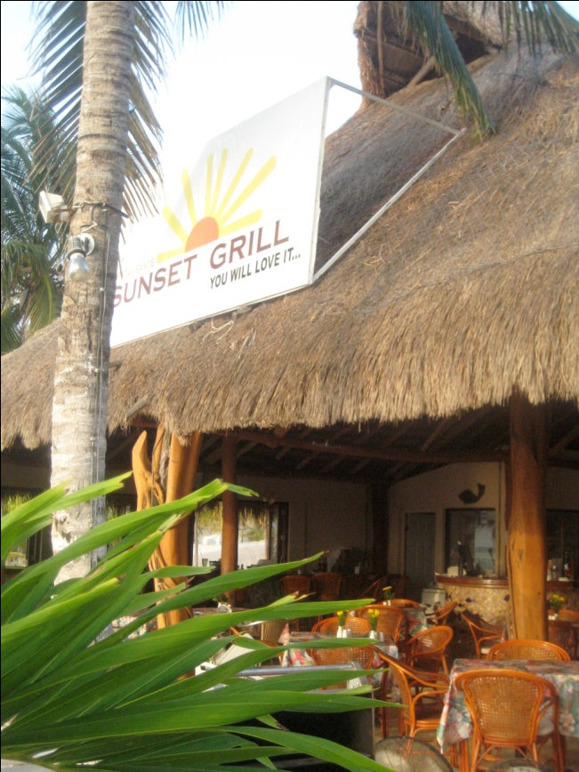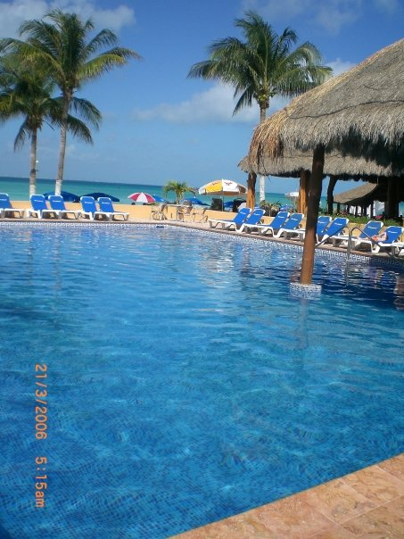
Sunset Grill
Sunset Grill This is where we spend most of our days. It is normally the meeting place when we have large groups. They have a large palapa and a wonderful view of the beach. They have a good lunch menu and Wi-Fi access. The Sunset Grill is located on Playa Norte next to Nautibeach Condos. This restaurant has a wonderful atmosphere and good food at reasonable prices.
Breakfast, Lunch & Dinner
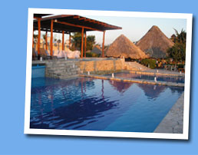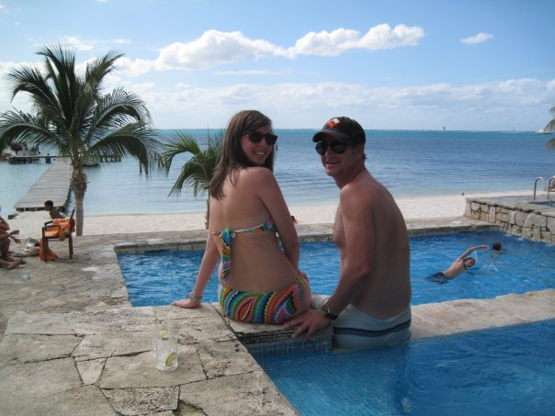
ZAMA’s
ZAMA’s Beach Club is a public beautiful open air palapa restaurant located on Sac Bajo with a small beach and a view of Cancun across the bay. There is no admission however they expect for you to eat or drink while you are there. It has three lovely pools with a waterfall and large plush beach chairs. Zama’s is so lovely that most of the Island’s weddings are held here.

